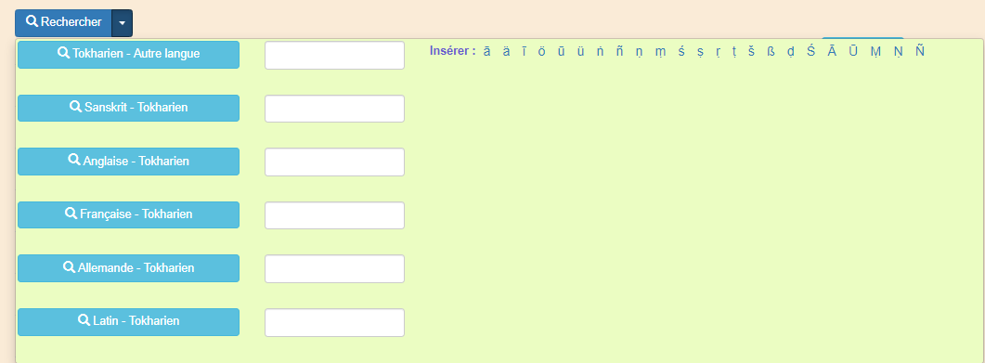

<style>

ul.dropdown-menu {

background-color: #ebfdc2;

color: slateblue !important;

padding: 2px;

width: auto;

}

.dropdown-submenu {

top: -20px;

Left: 100%;

margin-top: -1px;

}

.dropdown-submenu .dropdown-menu {

top: auto;

left: 100%;

margin-top: -1px;

display: none;

color: slateblue !important;

}

</style>

<div>

<div class="btn-group">

<button type="button" class="btn btn-primary"> <span class="glyphicon glyphicon-search"></span> @StaticResource.Resources.Search</button>

<button type="button" class="btn btn-primary dropdown-toggle" data-toggle="dropdown">

<span class="caret"></span>

</button>

<ul class="dropdown-menu" style="width: 1160px !important" role="menu">

<li>

<form class="form-group row" action="@Url.Action("SearchWord", "Vocabularies")" method="post" enctype="multipart/form-data">

<div class="form-group col-md-3">

<button type="submit" class="btn btn-info bigBtn" style="width:100%">

<span class="glyphicon glyphicon-search"></span> @StaticResource.Resources.Tocharian - @StaticResource.Resources.OtherLanguage

</button>

</div>

<div class="form-group col-md-2">

<input class="form-control" type="text" id="Search" name="search" />

</div>

<div class="form-group col-md-7">

<label for="search">@StaticResource.Resources.Insert : </label>

<a onclick="insertText('Search','ā');" href="#" style="font-size:medium; padding:5px"> ā </a>

<a onclick="insertText('Search','ä');" href="#" style="font-size:medium; padding:5px"> ä </a>

<a onclick="insertText('Search','ī');" href="#" style="font-size:medium; padding:5px"> ī </a>

<a onclick="insertText('Search','ö');" href="#" style="font-size:medium; padding:5px"> ö </a>

<a onclick="insertText('Search','ū');" href="#" style="font-size:medium; padding:5px"> ū </a>

<a onclick="insertText('Search','ü');" href="#" style="font-size:medium; padding:5px"> ü </a>

<a onclick="insertText('Search','ṅ');" href="#" style="font-size:medium; padding:5px"> ṅ </a>

<a onclick="insertText('Search','ñ');" href="#" style="font-size:medium; padding:5px"> ñ </a>

<a onclick="insertText('Search','ṇ');" href="#" style="font-size:medium; padding:5px"> ṇ </a>

<a onclick="insertText('Search','ṃ');" href="#" style="font-size:medium; padding:5px"> ṃ </a>

<a onclick="insertText('Search','ś');" href="#" style="font-size:medium; padding:5px"> ś </a>

<a onclick="insertText('Search','ṣ');" href="#" style="font-size:medium; padding:5px"> ṣ </a>

<a onclick="insertText('Search','ṛ');" href="#" style="font-size:medium; padding:5px"> ṛ </a>

<a onclick="insertText('Search','ṭ');" href="#" style="font-size:medium; padding:5px"> ṭ </a>

<a onclick="insertText('Search','š');" href="#" style="font-size:medium; padding:5px"> š </a>

<a onclick="insertText('Search','ß');" href="#" style="font-size:medium; padding:5px"> ß </a>

<a onclick="insertText('Search','ḍ');" href="#" style="font-size:medium; padding:5px"> ḍ </a>

<a onclick="insertText('Search','Ś');" href="#" style="font-size:medium; padding:5px"> Ś </a>

<a onclick="insertText('Search','Ā');" href="#" style="font-size:medium; padding:5px"> Ā </a>

<a onclick="insertText('Search','Ū');" href="#" style="font-size:medium; padding:5px"> Ū </a>

<a onclick="insertText('Search','Ṃ');" href="#" style="font-size:medium; padding:5px"> Ṃ </a>

<a onclick="insertText('Search','Ṇ');" href="#" style="font-size:medium; padding:5px"> Ṇ </a>

<a onclick="insertText('Search','Ñ');" href="#" style="font-size:medium; padding:5px"> Ñ </a>

</div>

</form>

</li>

<li>

<form class="form-group row" action="@Url.Action("SearchSanskrit", "Vocabularies")" method="post" enctype="multipart/form-data">

<div class="form-group col-md-3">

<button type="submit" class="btn btn-info bigBtn" style="width:100%"> <span class="glyphicon glyphicon-search"></span> @StaticResource.Resources.Sanskrit - @StaticResource.Resources.Tocharian </button>

</div>

<div class="form-group col-md-2">

<input class="form-control" type="text" id="Search" name="search" />

</div>

</form>

</li>

<li>

<form class="form-group row" action="@Url.Action("SearchEnglish", "Vocabularies")" method="post" enctype="multipart/form-data">

<div class="form-group col-md-3">

<button type="submit" class="btn btn-info bigBtn" style="width:100%"> <span class="glyphicon glyphicon-search"></span> @StaticResource.Resources.English - @StaticResource.Resources.Tocharian </button>

</div>

<div class="form-group col-md-2">

<input class="form-control" type="text" id="Search" name="search" />

</div>

</form>

</li>

<li>

<form class="form-group row" action="@Url.Action("SearchFrench", "Vocabularies")" method="post" enctype="multipart/form-data">

<div class="form-group col-md-3">

<button type="submit" class="btn btn-info bigBtn" style="width:100%"> <span class="glyphicon glyphicon-search"></span> @StaticResource.Resources.French - @StaticResource.Resources.Tocharian</button>

</div>

<div class="form-group col-md-2">

<input class="form-control" type="text" id="Search" name="search" />

</div>

</form>

</li>

<li>

<form class="form-group row" action="@Url.Action("SearchGerman", "Vocabularies")" method="post" enctype="multipart/form-data">

<div class="form-group col-md-3">

<button type="submit" class="btn btn-info bigBtn" style="width:100%"> <span class="glyphicon glyphicon-search"></span> @StaticResource.Resources.German - @StaticResource.Resources.Tocharian</button>

</div>

<div class="form-group col-md-2">

<input class="form-control" type="text" id="Search" name="search" />

</div>

</form>

</li>

<li>

<form class="form-group row" action="@Url.Action("SearchLatin", "Vocabularies")" method="post" enctype="multipart/form-data">

<div class="form-group col-md-3">

<button type="submit" class="btn btn-info bigBtn" style="width:100%"> <span class="glyphicon glyphicon-search"></span> @StaticResource.Resources.Latin - @StaticResource.Resources.Tocharian</button>

</div>

<div class="form-group col-md-2">

<input class="form-control" type="text" id="Search" name="search" />

</div>

</form>

</li>

</ul>

</div>

</div>

@section Scripts {

@Scripts.Render("~/bundles/jqueryval")

<script>

function insertText(elemID, text) {

document.getElementById(elemID).value += text;

}

</script>

}